UpTrend Excel Certification Course
Sign in Process for Students:

- Create an Account:
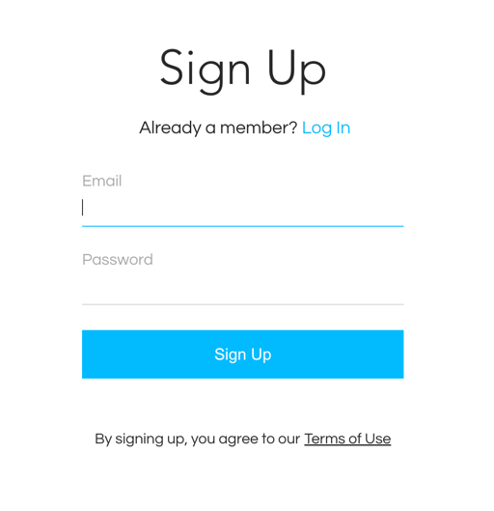

- Confirm your email with a 6-digit code:
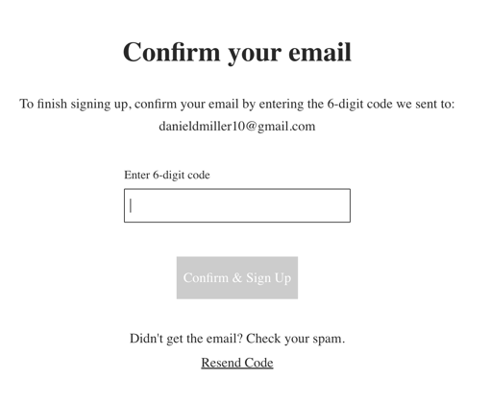

- Enter your first and last name to access the course:
